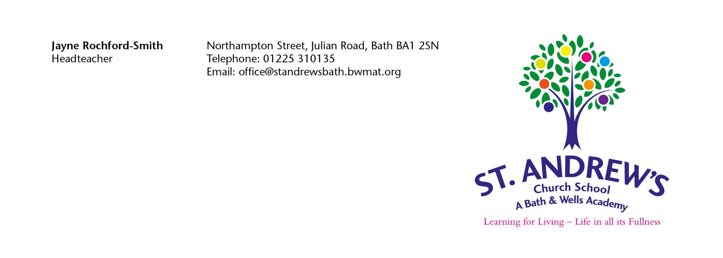
Dear Parent/Carer,

Thank you for expressing an interest in attending our Foundation Stage unit. Please find enclosed an Application form for your completion; however please be aware that these forms do not guarantee a place in the event of us being oversubscribed.

Please fill out the enclosed forms, indicating when you would like your child to start and then tick your first and second preferences for sessions. All sessions are allocated for the whole year and we will only be able to change sessions in exceptional circumstances, at the beginning of Terms 3 and 5. This, of course, will be fully dependent on spaces available.

Lunchtime is included in the daily routine for afternoon or full day sessions. Any child wishing to attend for a full day, or an afternoon session can buy a school dinner for £2.80, or they need to bring their own packed lunch.

Are foundation stage class places full time or part time?
At St Andrew’s places are offered on a part-time, sessional basis during term time only.

How much will the place cost?
Your child will be entitled to 15 hours free childcare (5 sessions) through the Early Years Entitlement Funding. In some cases depending on eligibility your child may be entitled to 30 hours free childcare (10 sessions). If you have requested additional paid sessions for your child, a session is 3 hours and is charged at an hourly rate of £5.00 (£15 per session). All payments are to be paid termly in advance on ParentPay and are non-refundable in any event.

If you would like to check your eligibility for the 30 hours free childcare, please visit www.childcarechoices.gov.uk . If you would like more information on what you are entitled to, contact the Childcare Choices helpline on 0300 123 4097.

When can my child start in the foundation stage class?
Providing there is an available space, your child will be able to join a nursery class at the beginning of term 1, 3 and 5 following your child’s third birthday if they fall with in the early year’s criteria.

How are foundation stage class places allocated?
The criteria for allocating places in Bath and North East Somerset are as follows.
Priority will be given in this order:
- Children identified as having special circumstances (no more than 10% of the total number of places)
- Children with brothers or sisters already at St Andrew’s School
- Children whose parents/carers are members of St Swithin’s Church
- Children whose parents/carers are members of other churches
- Children whose parents/carers are members of staff for a minimum of two consecutive years at the time of application.
- Children who live closest to the school in the local area

You don’t have to apply for the nursery class nearest to where you live, but you do have the best chance of being offered a place there. The distance you live from the school is also considered if the nursery class is over subscribed.

Attendance at a local authority nursery class attached to a school does not guarantee a place at the school when early year’s education is completed. You will need to apply for a school place through the school’s admissions procedure.

Nursery Application Form for St Andrews Church School

1. Name of child…………………………………………….……Date of birth……….…………….……

Male: Female:

Child’s position in family: for example, youngest of three…………………............................................

………………………….……………………………………………………………………………………….

Child’s home address: ……………………………………………………………………….….…………...

…………………………………………………………………………………………………………………..

Postcode: …….………….……………………… Home telephone: …….………….………………………

Work telephone ………...………………….…. Mobile telephone: ………….…...…...……………………

Email address: ……………………………………………………………………………………………….

2. Name of older sibling(s) attending the Infant or Primary School where the Foundation Stage

Class is based (if any) ……………………………………………...……….……………….………………...

Date of birth of sibling(s)……………………………...……………………...………………………………...

3. Does your child have any of the special circumstances listed below? Please tick those that apply to your child.
YES NO
- English is an additional language to that normally used by the child or the
Family
- The child’s home situation means that there is little interaction with other children
- The child has a brother or sister with a high level of special educational needs
- There is concern, by a Health Professional, that the child has failed to meet developmental targets
- The child has been assessed under the SEN Code of Practice as likely to experience difficulties when of school age
- The child’s behaviour has proved difficult to manage in the home or pre-school situation

Please complete this section if you have ticked ‘yes’ in Section 3

Describe the special circumstances, which you believe, apply to your child……………….……………. ………………………………………………………………………………………………………………………………………………………………………………………………………………………………………………………………………………………………………………………………………………………………………………
Please attach a letter from your social worker, health visitor or other professional in support of your application.

4. Please give religious affiliation and church attended, if appropriate…...…………………...…………

…………………………………………………………………………………..……………………..………

Nursery Application Form for St Andrews Church School
Month | Year | Your child can start if they are 3 years old on or before
September |  | 31st August
January |  | 31st December
April |  | 31st March
After their 3rd Birthday on a paid for basis. Please specify start date required:

Please choose the month you would like your child to start, after their 3rd birthday……………….
Please indicate on the table below your first and second preferences for sessions for your child.
- Please choose 15 hours free childcare (5 sessions if entitled to early years funding) or 30 hours free childcare (10 sessions if entitled to early years funding) from the choices as set out below for your child. This can be all mornings, all afternoons, or a mixture of both.
- If your child is staying for a full day or afternoon session you will need to order a school dinner at a cost of £2.80 or bring a packed lunch.
- Please indicate first and second preferences with a tick and additional paid sessions with a “P”

FIRST PREFERENCE | Morning Session  (3 hours) 8.55 -12.00 | Afternoon Session  (3 hours) 12.00-3.15
Monday
Tuesday
Wednesday
Thursday
Friday

SECOND PREFERENCE | Morning Session  (3 hours) 8.55 -12.00 | Afternoon Session  (3 hours) 12.00-3.15
Monday
Tuesday
Wednesday
Thursday
Friday

If you have an eligible 30-hour free childcare code, please can you complete the details below and sign the form to give us consent to check the validity of the code.

30-hour code………………………………………....................................................................................................................

National insurance number …………………………………………………………………………………………………………………………………

Name of Parent/Carer who applied for the code…………………………………………………………………………………………………

Date of birth of Parent/Carer who applied for the code …………………………………………………………………………………….

My child attends another nursery* ………………………………………………………………................

*Please provide details of other nursery(s) your child attends. If you have left this section blank, we will assume that you child does not attend any other nursery and you will let us know if the situation changes.

Name of Parent/Carer………………………...………………………………………… (Mr/Mrs/Ms/Miss)

Signature………………………………….………………...……………………. Date………………………

Please return this form to:
St Andrew’s Church School, Northampton Street, Julian Road, Bath BA1 2SN Tel: (01225) 310135

