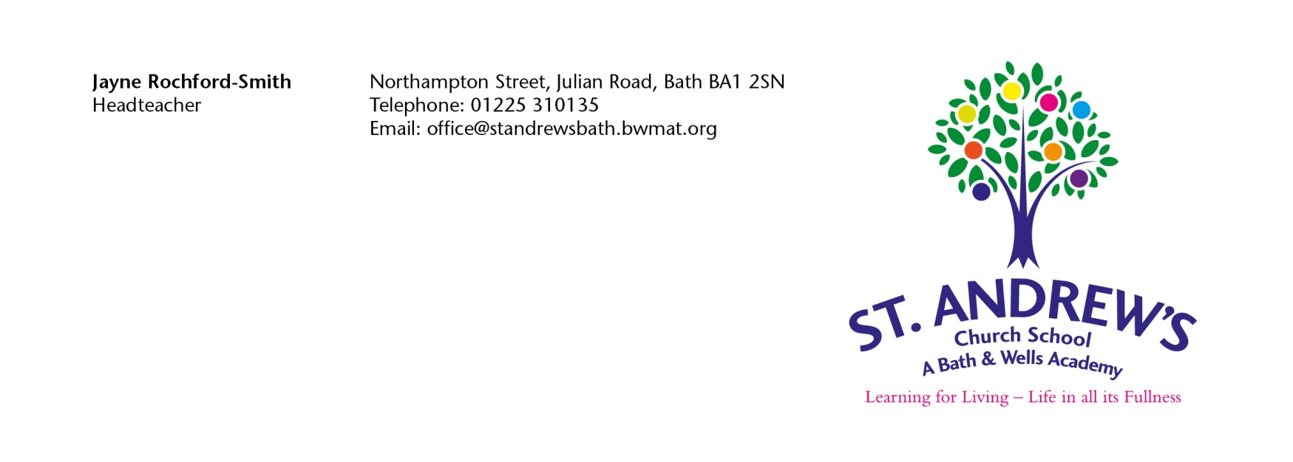
Appeal Form for St Andrew’s Church School ICS Form

This form should only be used if you wish to make a formal appeal for a place at St Andrew’s Church School. Please note you have 20 school days from the date of the notification letter within which to prepare and lodge your appeal.

Once completed please return the appeal form to the above address.

Infant Class Size - Government legislation means that infant classes (Reception, Year 1 and Year 2) with one teacher cannot contain more than 30 pupils. When considering an appeal for a place in an infant class the independent appeal panel’s task is to review the decision already made. It does not have the flexibility to say that the appellant’s personal circumstances mean that they should have a place at the school if this would take the number of children in the school class over 30. This makes an infant class size appeal different to other school admission appeals.

At Infant Class Size Appeals the independent appeal panel can only look at:

- Whether the admission arrangements were lawful
- Whether the admission arrangements were incorrectly applied and your child should have been offered a place.
- Whether it was unreasonable/perverse (in law) to refuse your preference. The appeal panel would need to be satisfied that the decision was so completely absurd / outrageous that no reasonable person, with the same facts, would have made that decision.

Given the extremely limited grounds on which an appeal may be upheld, Infant Class Size Appeals are very rarely successful. Most applicants who have been refused a place at their preferred school consider the refusal to be perverse but as mentioned above the word has a stronger meaning in its legal sense.

Parents/carers can find it frustrating when they realise how very limited the powers of the Appeal Panel are when considering Infant Class Size appeals. We are therefore drawing this to your attention now, so you can make an informed decision about whether you wish to appeal or not. The purpose of this information is to explain clearly the role of the Appeal Panel and not in any way discourage you from appealing, which is of course, your legal right if you feel you have grounds to do so.

As this form will be photocopied, please complete it in BLACK ink.

Full Name of Child:
Child’s Date of Birth:
Address of Child: | Postcode:
Written By:  Please Print Name of Parent/Carer & indicate title | Title: Mr/Mrs/Ms/Other
Signature of Parent/Carer: | _________________________Date:____________
Daytime Telephone Number(s): | Home:  Mobile:
Name of School Appealing for and Preference Number: | Preference No (i.e., 1st,2nd,3rd)

Grounds for Appeal.

Any information you wish to submit in support of your appeal should be sent in by you, if possible, with your letter of appeal.

Please indicate if supporting evidence is included with this appeal letter. YES/NO (delete as appropriate)

The appeal for the school is expected to be heard in the context of infant class size, please indicate which of the restricted circumstances you believe applies to your case.
Tick Box
a)The admissions arrangements were not lawful

b)The admission arrangements were not correctly applied and if they were my child would have been offered a place

c)The decision not to offer my child a place was unreasonable/perverse in a legal sense

Please use the space below to set out the grounds for your appeal and if necessary attach a separate sheet.

Grounds For Appeal
If attaching additional sheets please tick this box

