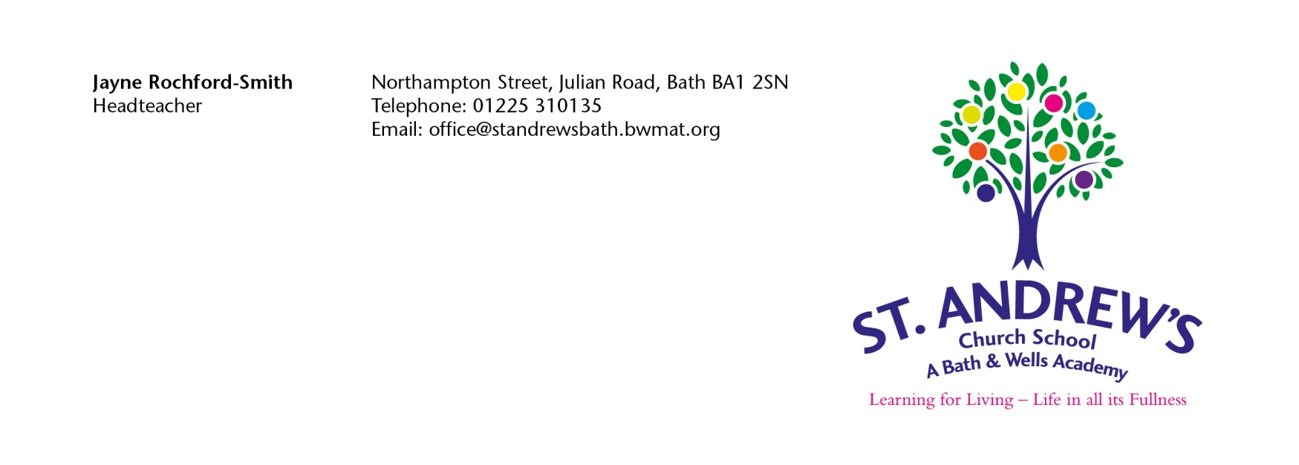
Appeal Form for St Andrew’s Church School ICS Form

This form should only be used if you wish to make a formal appeal for a place at St Andrew’s Church School. Please note you have 20 school days from the date of the notification letter within which to prepare and lodge your appeal.

Once completed please return the appeal form to the above address.

As this form will be photocopied, please complete it in BLACK ink.

Full Name of Child:
Child’s Date of Birth:
Address of Child: | Postcode:
Written By:  Please Print Name of Parent/Carer & indicate title | Title: Mr/Mrs/Ms/Other
Signature of Parent/Carer: | _________________________Date:____________
Daytime Telephone Number(s): | Home:  Mobile:
Name of School Appealing for and Preference Number: | Preference No (i.e., 1st,2nd,3rd)

Reasons for Preference/Grounds for Appeal.

Any information you wish to submit in support of your appeal should be sent in by you, if possible, with your letter of appeal.

Please indicate if supporting evidence is included with this appeal letter. YES/NO (delete as appropriate).

Please use the space below to set out the reason for preference or grounds for appeal and if necessary, attach a separate sheet.

If attaching additional sheets please tick this box

