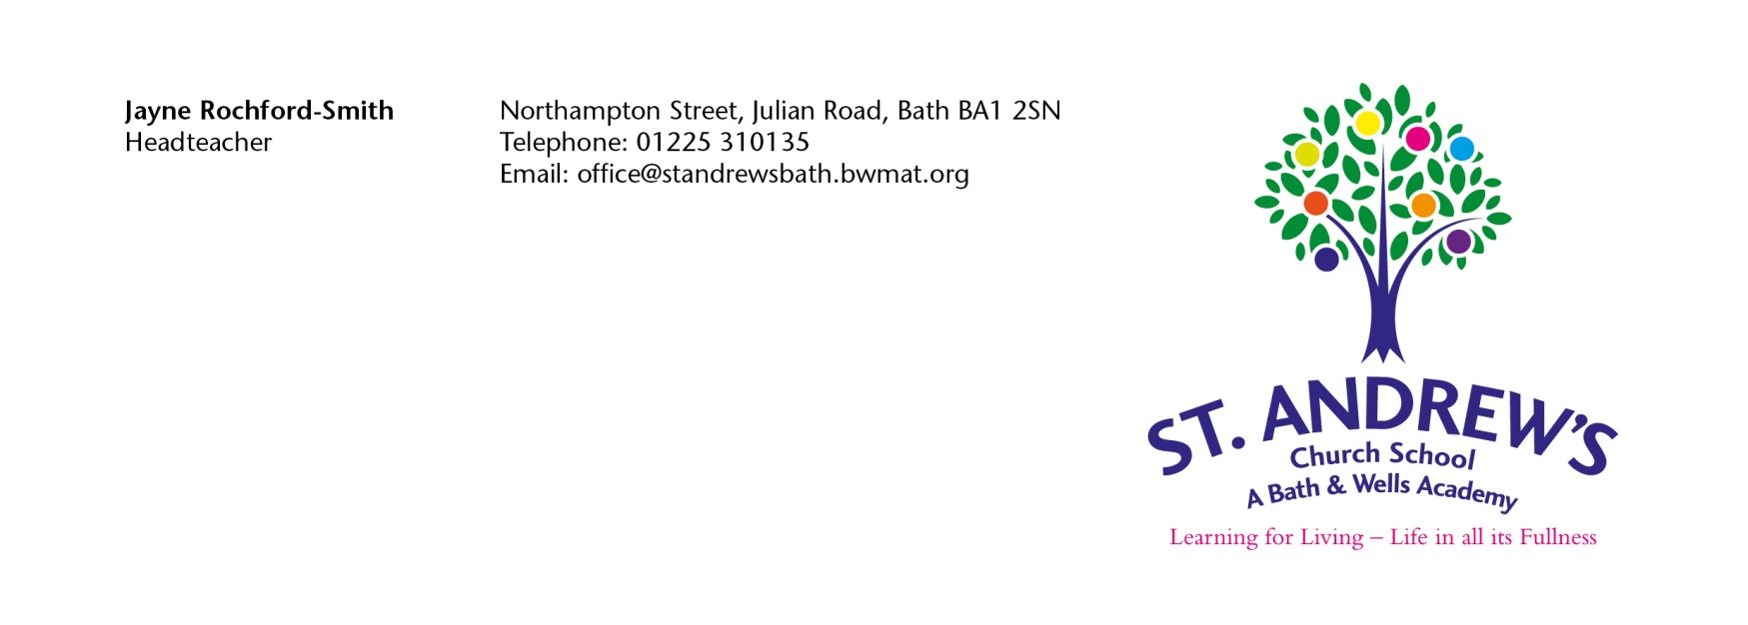
Dear Parent/Carer,

Thank you for expressing an interest in attending St Andrew’s Church School Nursery. Please find enclosed an application form for you to complete and return to the school office.

Please fill in the enclosed forms, indicating when you would like your child to start and then tick your preference for sessions. All sessions are allocated for the whole school year and will only be able to be changed at the beginning of terms 3 and 5 by returning a completed amendment form to the school office. This, of course, will be dependent on space available. 4

Lunchtime is included in the daily routine for a full day or afternoon session. Any child attending a full day or afternoon session will need to book and pay for a school meal (£2.90) on Parentpay or bring a packed lunch in from home.

Are nursery class places full time or part time?

At St Andrew’s Church School Nursery places are offered on a full time or part-time basis during term time only.

How much will the place cost?

Your child is entitled to 15 hours funded childcare (5 sessions) through the Early Years Entitlement Funding starting the term after your child’s third birthday. If you have requested additional paid for sessions for your child, a session is charged at £15.50 per session, £31 for the full day. All payments are to be paid termly in advance on ParentPay and are non-refundable in any event. Please refer to St Andrew’s Church School Nursery Charging Policy for further details.

In some cases, depending on eligibility your child may be entitled to 30 hours funded childcare (10 sessions).
To check whether your child is eligible for the 30 hours funded childcare, please visit https://www.gov.uk/apply-30-hours-free-childcare

When can my child start in Nursery?

Providing there is an available space, your child will be able to join the nursery class at the beginning of term 1, 3 and 5 following your child’s third birthday if they fall with in the early year’s criteria.

How are nursery class places allocated?

Where there are more applications than places available, places will be offered on line with the priority order below.

- Children Looked After – Children who are in the care of a Local Authority or have previously been and are now formally adopted or subject to a residence/child arrangement order or special guardianship order. Children who appear (to the admission authority) to have been in state care outside of England and ceased to be in state care as a result of being adopted.
- Children in receipt of funding for additional educational needs.
- Children who, at the time of application, have a sibling attending St Andrew’s Church School.
- Children who live within the City of Bath and the family are ‘practising’ members of any Church.
- Children living closest to the school, as measured in a direct line.

You do not have to apply to a Nursery nearest to where you live, but you do have the best chance of being offered a place there. The distance you live from the Nursery is also considered if the nursery class is over subscribed.

Attendance at a local authority Nursery attached to a school does not guarantee a place at the school when early year’s education is completed. You will still need to apply for a reception school place through the Local Authorities school’s admissions procedure.

Nursery Application Form for St Andrews Church School

1. Name of child…………………………………………….…………………………. Date of birth……….…………….……

Male: Female

Child’s position in family: for example, youngest of three…………………............................................
………………………….………………………………………………………………………………………………………………………….

Home address: ……………………………………………………………………….….…………........................................

…………………………………………………………………………………………………………………………………………………….

Postcode: …….………….………………………………….… Home telephone: …….………….…………………………….

Work telephone ………...…………………………………..Mobile telephone: ………….…...…...……………………..

Email address: …………………………………………………………………………………………………………………………….

2. Name of older sibling(s)

Class ……………………………………………...……….……………….………………....................................................

Date of birth of sibling(s)……………………………...……………………...……………………………….......................

3. Does your child have any of the following: - Please tick those that apply to your child.
YES NO
- English is an additional language to that normally used by the child or the
family
- The child’s home situation means that there is little interaction with other children
- There is concern, by a Health Professional, that the child has failed to meet developmental targets
- The child has been assessed under the SEN Code of Practice as likely to experience difficulties when of school age
- The child’s behaviour has proved difficult to manage in the home or pre-school situation

Please complete this section if you have ticked ‘yes’ in Section 3

Please describe the circumstances, which you believe, apply to your child……………….……………. ………………………………………………………………………………………………………………………………………………………………………………………………………………………………………………………………………………………………………………………………………………………………………………
Please attach a letter from your social worker, health visitor or other professional in support of your application.

4. Please give religious affiliation and church attended, if appropriate…...…………………...…………

…………………………………………………………………………………..……………………..………………………………

Nursery Application Form for St Andrews Church School
Month | Year | Your child can start if they are 3 years old on or before
September |  | 31st August
January |  | 31st December
April |  | 31st March
After their 3rd Birthday on a paid for basis. Please specify start date required:

Please indicate on the table below your preference for sessions for your child.
- Please choose 15 hours funded childcare (5 sessions if entitled to early years funding) or 30 hours funded childcare (10 sessions if entitled to early years funding) from the choices as set out below for your child. This can be all mornings, all afternoons, or a mixture of both.
- If your child is staying for a full day or afternoon session you will need to book and pay for a school meal (2.90) on Parentpay or bring a packed lunch in from home.
- Please indicate your preference with a tick for funded hours and a “P” for additional paid sessions.

PREFERENCE | Morning Session  8.55am-12.00pm | Afternoon Session  12.00-3.05pm
Monday
Tuesday
Wednesday
Thursday
Friday

If you have an eligible 30-hour funded childcare code, please can you complete the details below and sign the form to give us consent to check the validity of the code.

30-hour code………………………………………....................................................................................................................

National insurance number …………………………………………………………………………………………………………………………………

Name of Parent/Carer who applied for the code…………………………………………………………………………………………………

Date of birth of Parent/Carer who applied for the code …………………………………………………………………………………….

My child attends another Nursery* ………………………………………………………………................

*Please provide details of other Nursery(s) your child attends. If you have left this section blank, we will assume that you child does not attend any other Nursery and you will let us know if the situation changes.

Name of Parent/Carer………………………...………………………………………… (Mr/Mrs/Ms/Miss)

Signature………………………………….………………...……………………. Date………………………

All data is collected in line with our Privacy Notice and Data Protection Policy which can be found at
BWMAT Key Policies – BWMAT

Please return this form together with a copy of your child’s birth certificate to:
St Andrew’s Church School, Northampton Street, Julian Road, Bath BA1 2SN Tel: (01225) 310135

